OOP Lab 4 : Classes, Objects, and Object Interaction in C++
Exercise 1: Create a class named Student.
- Declare the following data members as private:
- rollNo (int)
- marks (int)
- Declare the following member functions as public:
- setData() to assign values to the data members
- display() to print student details In main():
- Create an object named s1
- Store and display the student details using public member functions
Ans -
Code :
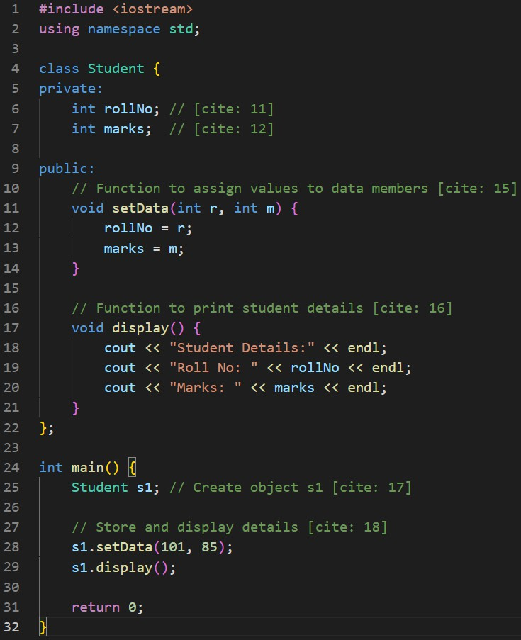

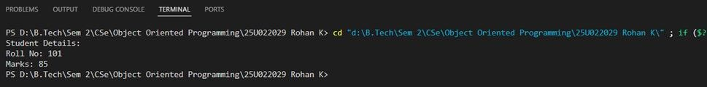

Exercise 2: Create a class named Number.
- Declare one private data member:
- value (int)
- Declare a default constructor that initializes value to 10
- Declare a public member function show() to display the value In main():
- Create an object named n1
- Display the initialized value
Ans -
Code :
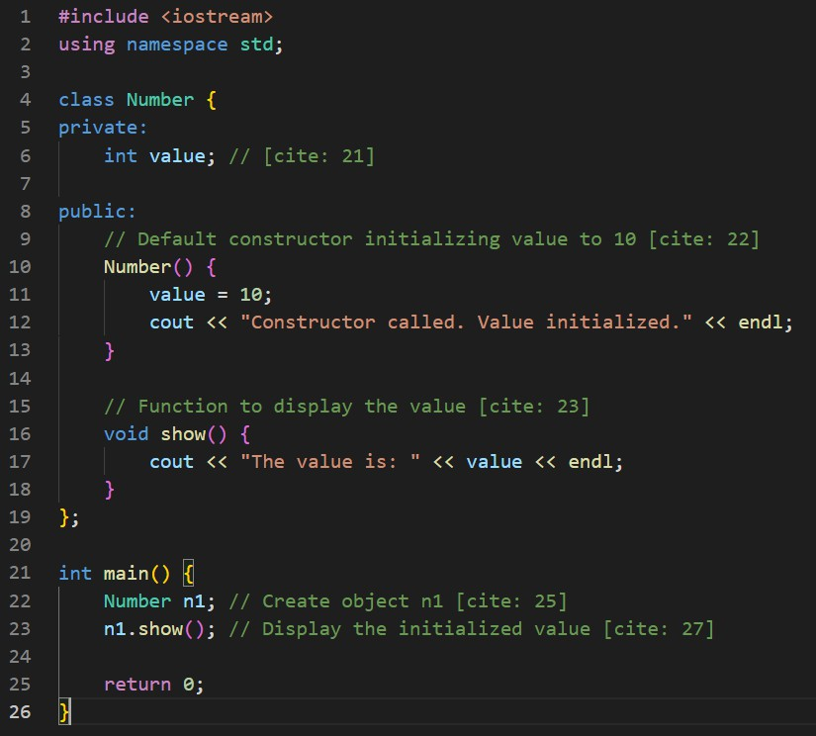

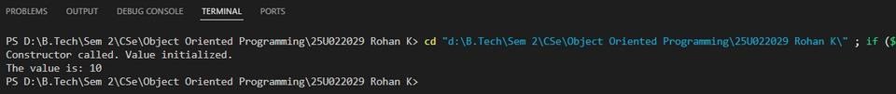

Exercise 3: Create a class named Rectangle.
- Declare the following data members as private:
  - length (int)
  - width (int)
- Declare the following member functions as public:
  - setDimensions(int l, int w)
  - calculateArea()
  - displayArea() In main():
- Create an object named rect1
- Set dimensions and display the area
Ans -
Code :
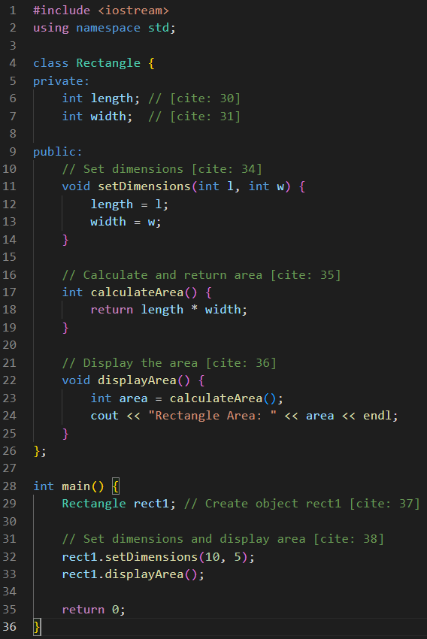

Exercise 4: Create a class named BankAccount.
- Declare the following data member as private:
  - balance (double)
- Declare the following member functions as public:
  - setBalance(double amount)
  - getBalance() In main():
- Create an object named acc1
- Set and retrieve the balance using public functions only
- Do not access the private data member directly
Ans -
Code :
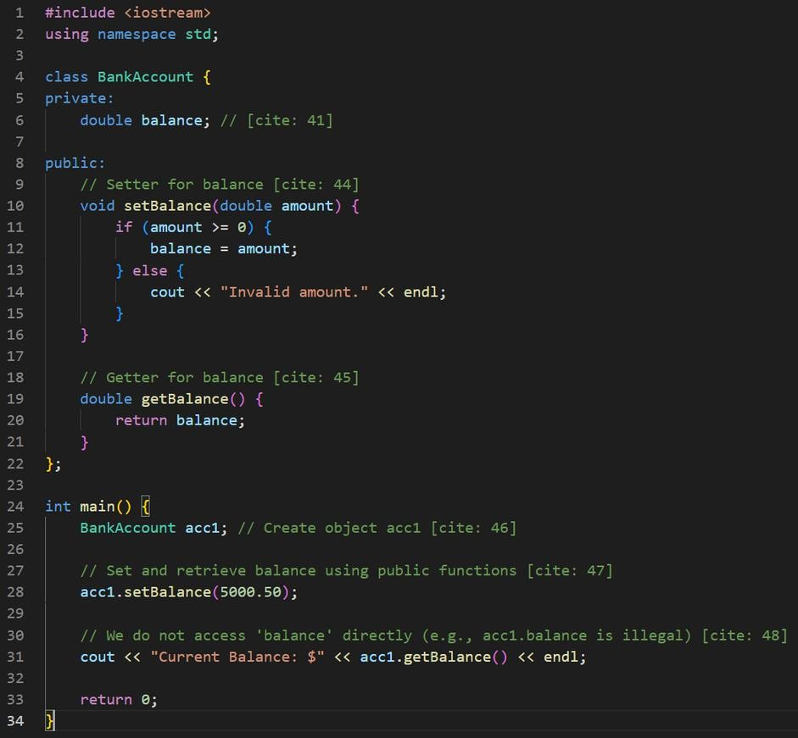

Exercise 5: Create a class named Employee.
- Declare the following data members as private:
  - empId (int)
  - salary (float)
- Declare the following member functions as public:
  - setData(int id, float sal)
  - showData() In main():
- Create an array of three objects named emp[3]
- Store and display employee details using loops
Ans -
Code :
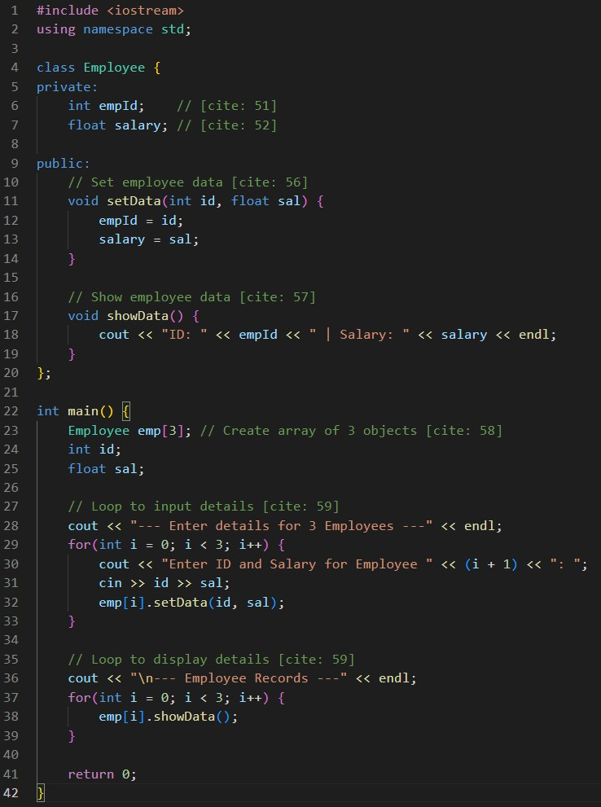

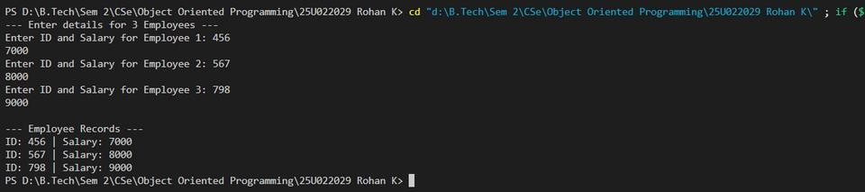

Exercise 6: Create two classes named Author and Book. Class Author
- Private data member:
  - name (string)
- Public member functions:
  - setName(string n)
  - getName()
Class Book
- Private data member:
  - title (string)
- Public member function:
  - display(Author a) to display book title and author name In main():
- Create objects a1 (Author) and b1 (Book)
- Pass the Author object to the Book object
Ans -

Code :
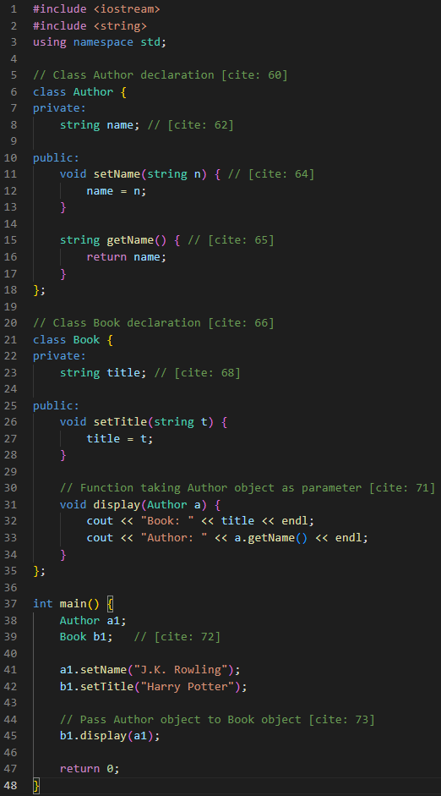

Output :
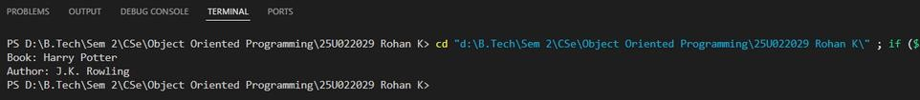

Exercise 7: Create a class named Demo.
- Declare a private data member:
  - num (int)
- Declare public member functions:
  - set(int num) using the this pointer
  - show() to display the value In main():
- Create an object named d1
- Call both functions
Ans -
Code :
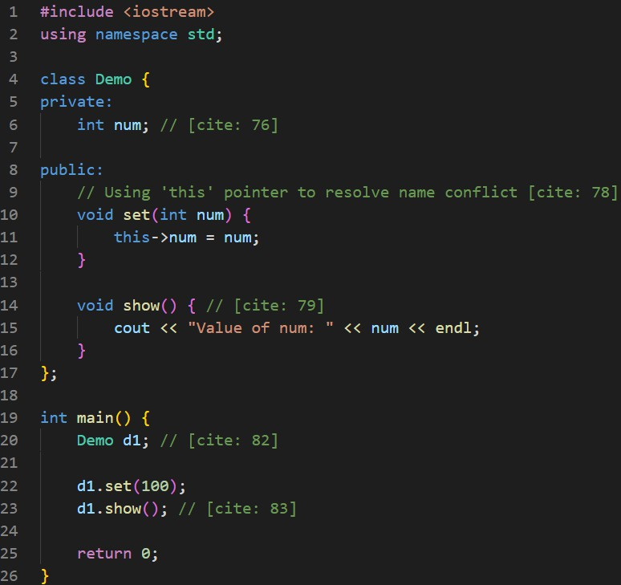

Exercise 8: Create a class named Sample.
- Declare a public data member:
– x (int)
Write a function named modify():
  - Accepts a Sample object by value
  - Modifies the value of x
In main():
  - Create an object named obj1
  - Show that changes inside the function do not affect the original object
  - Explain why the object address and its copy are different
Ans -
Code :
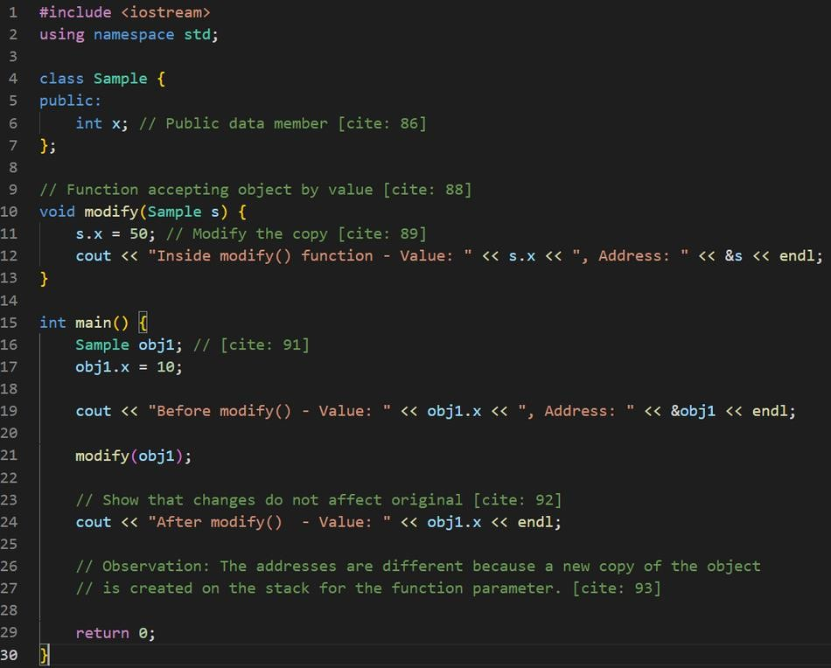

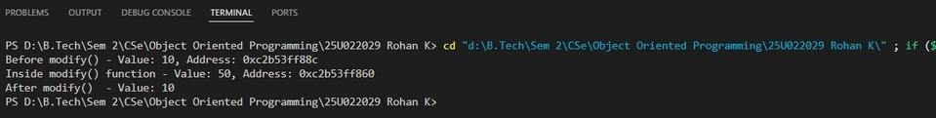

Exercise 9: Using the same Sample class from Exercise 8:
  - Write a function named modifyByAddress()
  - Accept a pointer to a Sample object
  - Modify the data member using pointer notation In main():
  - Create an object named obj2
  - Pass its address to the function
  - Show that the changes affect the original object
  - Access object data using both object and pointer
Ans -
Code :
